Remembering Norman Ingram

As many of you may have heard, a devoted Urantia Book reader named Norman Ingram passed away today. Norman was truly one of the greatest promoters of the revelation!
Back in 1998 Norman needed funds for his "Mission to Africa" to place Urantia Books from north to south in libraries, educational institutions, prisons, and in the hands of truth seekers he chanced to meet along the way. This inspired me to collect "How I Found the Urantia Book" testimonies and publish them in a book which would be offered for a $20 donation, the profits (after printing costs of around $7 per book) going towards Norman’s travel expenses. My plan worked! Through a vigorous two-months-long email campaign—March-April 1998—I accumulated a total of 223 accounts and we sent Norman over $7,000, which helped to make his African mission a success!
Between missionary travels, Norman operated a Urantia Book booth on Venice Beach, California (photo #1) where curious truth seekers would stop by and ask questions about the Urantia Book. The other picture is of me with Norman at an LA Urantia gathering around 2000. See you on the mansion worlds, Norman!
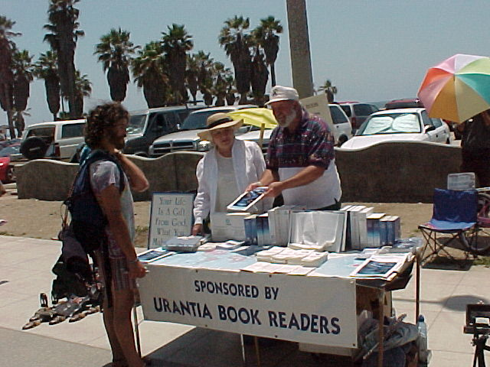
Circa 2000: Norman Ingram with Polly Friedman sharing the revelation with passersby on the boardwalk in Venice Beach.
****
Norman had a deep understanding of how important it is to get the revelation into the world and into the lives of individual persons. He pursued this vision to the limits of his abilities and resources--and then some! He was perhaps the first true missionary of the fifth epochal revelation in the tradition of the Melchizedek missionaries, those sent out by Asoka, the early evangelists of the fourth epochal revelation, and many other individuals living for their vision of the kingdom of God on earth. Blessings on your journey, Norman. "The revelation of God to the world, in and through Jesus, shall not fail."

David Kantor
*************************
Below is Norman's own story (page 102 of the revised HIFTUB):

NORMAN INGRAM
In 1971 the big change came into my life. I’d had several years of success as a sales mechanical engineer for a company that owned five of the thirteen working sugar plantations in Hawaii in those days. Flying was my hobby, and I owned an aircraft dealership/flight school at the Honolulu International Airport.
My new wife Lyn and I were expecting our first child. We were living in a big, old, beautiful two-story lava stone house on the beach in Waiminloa. It had a circular driveway and was surrounded by many coconut and ironwood trees. Inasmuch as we had a big house on the beach we never lacked houseguests, and this was fine with us because we liked their company. If you stayed up to two weeks, you were considered a guest; if you stayed longer, you were a housemouse.
One such housemouse was a young fellow named David Diggs. He had been staying with us for about four months when he came into my study one day and began to tell me about a book. “Knowing you,” he said, “I know you will be interested in this.” I asked him what the book was about. “Science and philosophy,” was his answer.
He then handed me a big, stately, impressive-looking blue book. I began by carefully scrutinizing the table of contents. I could not believe what I was reading. I was amazed at the range of subject matter covered in this book. I got through the Foreword and was totally blown away. I lost track of time, reading day and night, not conscious of anything going on around me. After about four days, on a Sunday morning around ten o’clock, I flipped to the front of the book to see if there was any information about someone I could talk to about this marvelous revelation.
In fine print I found mention of the Urantia Foundation at 533 Diversey Parkway in Chicago. I called directory assistance, got their number, and made the call.
A sweet voice answered, “This is Christy.”
I told her that I had received the Urantia Book three or four days earlier and that I had gone into a time warp, so fascinated was I by the truths I was finding in this book. She laughed and offered to send me some literature about the Foundation and the Brotherhood. Before we hung up I asked her if she knew of any other Urantia Book readers in Hawaii. Christy then told me about her friend Le’Ruth Ward Tyau, a Mormon and a mother with many children, who wrote children’s books using UB concepts.
As soon as I finished talking with Christy, I called Le’Ruth in Honolulu and arranged to have lunch with her the next day. I had to meet her to give her a pinch to see if she was real. How could anyone read these truths, know the concepts of this revelation, and still exist on this planet? She was a real and a pleasant delight. As we parted I asked her if she knew of anyone else on the island who was reading the book, and she told me that there were about half a dozen women who regularly got together for a study group.
I raised my hand and volunteered our home for these studies. It was great meeting all the other people in the group. Not long after that, we opened a booth at Diamond Head Crater where we sold organic juices poured over shaved ice at rock concerts. With the profits we bought Urantia Books and donated them to local libraries in Hawaii. In those days Big Blue cost only $12.50. Occasionally we would check back with the libraries, and if a copy was missing we would replace it.
Later I arranged for the Foundation to ship ten used Urantia Books to supply the prisons. Over the years I have bought at least twenty books a year to give away to those truth-seeking mortals whom our Father has brought across my path.
The Urantia Book has answered all the fundamental questions I’ve ever had and it has raised twice as many more. It has inspired me to spread its truths to the nations of our lonely planet, and I will continue to do so as long as God gives me the strength, the faith, and the courage to do his will. Such a life on such a planet!

This is just a beautiful tribute to one of God's servants.

Norman had big plans and he fulfilled them in spiritually uplifting those he met by "passing by". Not everyone's mission covers such a large territory as Norman managed so beautifully. But he exemplifies all those who labor tirelessly in service wherever they are and make use of their talents and resources. We can admire him but more, take his attitude into our own hearts. Every day is a day to "romp and play in the Father's universe". And it can be done right were you are or further afield. It is those who listen to the whisperings of their inner voices who then do great things humbly and joyfully. Norman gave inspiration to many of us. Indeed, well done thou faithful servant. Well done!

Thank you, Paula, for sharing his story.

Eugenia

A Tribute to a True Urantian Evangel, Norman Ingram

I met Norman Ingram in 1980, at the Denver Study Group. Norman had come home to Colorado from Molokai, HI, and he went to work in Denver for Vital Signs, a sign company owned by another dear Urantia brother, Archie Anderson. (Archie graduated 25 years ago.) He was once a member of Rocky Mountain Spiritual Fellowship but later rescinded his membership because he didn’t want to take sides in the “split.” He later applied to be a Member at Large of the Fellowship but also joined every other Urantia organization that he could at that time, including the Teaching Mission.

He left the Rocky Mountain region and went back to Molokai for several years. It was a place he dearly loved. When he came back to the mainland in the mid-90s he was ready to go to work. We connected with each other again in San Francisco. I was managing a booth at the San Francisco Whole Life expo. We both stayed with Larry Geis at his mansion on Page St., and after the expo we drove down the coast for more Urantia outreach at an expo happening in LA the following weekend. That gave us plenty of time to catch up, and since I hadn’t seen him for several years it was a delightful road trip. He told me of his plans to take the Urantia Book around the world. He showed me a world map with little stick pins in it, which represented all the countries he planned to spread the book in. His main goal was to place books strategically in libraries, but also, with people and just anywhere and everywhere he could. The Fellowship together with Jesusonian Foundation were just then beginning to develop the Pipeline of Light, and so we supplied many of the books he used on his various excursions. It was on that car ride that he asked me to call him The Aloha Ambassador.

He met the late Stella Religa at that time and stayed on in LA with her. He didn’t go back to Hawaii. Stella and Norman were splendid together. He so loved and admired Stella. I complimented him on his stalwart service to the revelation one day, and he told me that Stella had recently been honored at a dinner held by the Governor of California. She was being celebrated for pioneering one of California’s first and most successful shelters for battered women. He said, “She’s the real hero. I felt like crawling under the table because I’m not worthy to be with her.” I assured him that he was very much worthy of all good things in his life, including and especially Stella.

His first great Urantia excursion was to Peru with Stella and other LA friends. It was there that he met Pradhana Fuchs, and gave him a Spanish book. Pradhana lovingly nicked named him, “Big Tree.” I felt blessed to meet Pradhana in Flagstaff, AZ, at the Fellowship’s International Conference, IC’96. Norman later went to Africa where he discovered a professor teaching 100 students with one Urantia Book. That professor’s name was Moussa Ndiaye. Well, you can imagine how overjoyed Moussa’s students were to have Norman deliver to them their very own Urantia Book to study. Moussa went on to be a beloved teacher in the Urantia Movement. Norman deeply loved and respected Moussa. It does my heart good to think of him making merry again with his friends Moussa, Archie, and Stella.

Norman was willing to sleep in a hut, or on the dirt, in places like Sierra Leone, where he witnessed the immense suffering of refugees and the aftermath of terrible violence. But he didn’t get discouraged. He used to call me and I’d ask him, “Hey Brother, how’s it going?” To which he would always reply, “Another day to romp and play in the Father’s Universe!”

He went back to Latin America, where he traveled extensively, and then on to China, placing Urantia Books everywhere along the way. He called his mission World Outreach to Urantia Nations. He was audacious and determined. God bless him for that! When he got too old to travel he was content to set up a booth on the boardwalk at Venice Beach. I doubt that we could count the people who learned about our marvelous revelation from Norman Ingram.

'Well done, good and faithful steward… enter you into the joy of your lord.'

Godspeed Brother Norman, until we meet again!

Love….Paula

It seems there have been many readers departing for the Mansion worlds of late. Norms passing is yet another reminder of how short our time on 606 is. Norm inspired me and many others to go further with our outreach endeavors. When in the LA area I enjoyed helping at the booth. It took a lot of dedication for Norm and friends to get a space, haul the supplies over, visit with passers by and haul everything back to the storage space when done.

Norm was the real deal. He was/is a humble, gentle soul and went way out of his way to share the revelation with his fellow humans. A great big THANK YOU to this mighty Soldier of the Circles.

Thomas

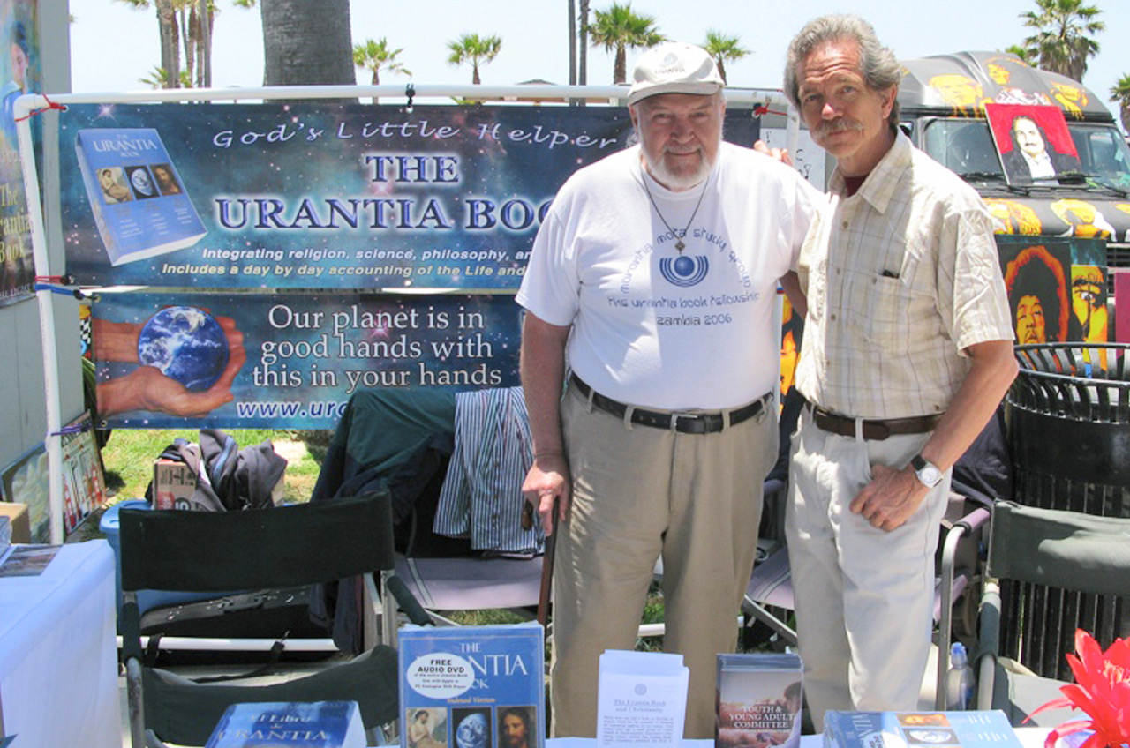
Sorry to hear that another champion of The Urantia Book Revelation has passed on from 606. The Mansion Worlds will be blessed with his presence and his zeal to share “Truth” with all his brothers and sisters! We will miss you here Norm, may you awaken to your new career in short order so you can begin where you left off here sharing your personal experience of GOD with all you come in contact with. I will miss him, even only have known him so little here.

See you on the other side Norm :)

Thank you,

Emilio Coppola

Hello All !

Norman Ingram was indeed one of the most dedicated and successful far-reaching "missionaries" for the Fifth Epochal Revelation to have come along to grace our sphere up to this time.
[For those who knew him personally, it must be included here that he had also the supreme additional and attractive qualities of being a wonderfully friendly, universally approachable, and
tactfully talented in sharing the new good news--and the timeless good news--with prospective beneficiaries of such blessings from virtually any background or established mindset. He
followed beautifully the Master's injunction to the apostles: "Strive not with men."]

Now that the Book is finding its way across our planet by electronic means, we might be inclined to overlook the era before that when physically taking the Book to prospective recipients
was the option open to would-be disseminators. Norman has recounted some amazing stories of how, again and again, the "way" for his missionary outreach adventures were auspiciously
"prepared" by unseen factors which must, Norman and others concluded, have had a hand (or a wing) in the overwhelming success-results to his faith-based missions. Norman's implicit
trust in the efficacy of the overlapping of his own efforts with those of the social architects and others we know about (and some--no doubt--about which we do not) augmented their conjoint
victorious achievements, mission after mission.

I am so pleased that it is Saskia, as indeed it should be, who is the one bringing us this story, celebrating Norman's achievements and commemorating his "graduation," as we look back
and read recounted, in her and in Norman's own words, the initial stages of his and her involvement in the rapidly burgeoning success of his outreach project.

You may recall the revelators' having candidly intimated to us how much they miss the astounding heroism and unconditional devotion of, first of the bravery and determination of primitive
man simply to survive and then to perpetuate his early achievements at civilization---and later of the zealous and seemingly unstoppable efforts of the Salemite missionaries and then of
the Sethite priesthood as they carried the lights of the spiritual illuminations and spiritual benefits of the Second and Third Epochal Revelations to Urantia, respectively, onward and outward,
irrepressibly into what were then certainly unknown regions for them--bearing the good news with them that they had received from on high to more and more members of the planetary
brotherhood---of the favorable (even loving) disposition of God's toward all his children and later of the effectiveness of simple faith in securing the assurances of survival and of everlasting
life----along with the immeasurable and unsuspected blessings and advantages to be attained in the unending course of that eternal career.

As we now sail over the Rockies, the Andes, and the Alps in jets--or cruise serenely over any ocean or sea in potential luxury, depending on our economic stratus--it may have become very
easy to forget or to dismiss the herculean efforts faced by earlier disseminators of truth who conquered these and other life-threatening and "insurmountable opportunities" in order to achieve
their ends--the ends also desired by the revelatory groups and individuals responsible for bringing such successive expansions of truth to humanity.

And in the case of the Fourth Epochal Revelation to Urantia, perhaps even more--we see that four of the twelve apostles followed their Master unflinchingly to the cross as others embraced
execution---as all (minus the twinsand Judas) went on in unconditional service as far as their strengths would carry them. And these records of purely human effort---distinct from those of
Christ Michael in unprecedented and astounding earth mission (magnificent and universally astonishing to the local universe--and beyond---as they were!)--continue to challenge to our own
resolve to respond to the same and ongoing injunction to: "go into all nations proclaiming the gospel of the Fatherhood of God and the worldwide brotherhood of man."

Norman Ingram was among those few who, thus far, and in relation to the Fifth Epochal Revelation, have more fully complied with that mandated injunction---who have completed a career of
successful and serviceful outreach to the citizens he encountered on and of Urantia. As we pause to reflect on Norman's life of dedication and to ponder the extent of his achievement for the
revelation---we are brought inevitably back to one or more of the revelators' own statements and reminders of the magnitude and potential significance, the possible world-transforming promise,
of the challenge, the opportunity, and the potential which ever stands before us---as expressed in this passage :

"All Urantia is waiting for the proclamation of the ennobling message of Michael, unencumbered by the accumulated doctrines and dogmas of nineteen centuries of contact with the
religions of evolutionary origin. The hour is striking for presenting to Buddhism, to Christianity, to Hinduism, even to the peoples of all faiths, not the gospel about Jesus, but the
living, spiritual reality of the religion of Jesus." (Melchizedek of Nebadon, 94:12.7) [1041]

Respectfully and joyfully submitted in celebration of Norman's achievements and his triumphant graduation,
David Glass

Good News! At 12:15am our BrotherFriend Norman D Ingram peacefully made his transition from this Life to the Next. He lived a devoted and passionate life of Seed Planting, Loving Ministry and Social Service. His last message was, “Be good to each other and remain Christ-Like!” :-)
Norman is survived by his sister Lia and his son "Lono" Eric Ingram. Condolences to Norman's family and his international circle of Close Friends. He will be greatly missed, until we meet again.
Gary Tonge Blessings on his ever widening adventure! 💙💙💙💙
Ladee Dred "HEAVEN IS A PLACE"....RIP!
Lucretia Schanfarber A sweet man.
David del Rio safe travels to him and peace within for those that mourn his passing.
June Humphreys R.I.P Amen.
Willie Stanley Livingstone May he rest in perfect peace and light shines in his path as he journeys to the mansion worlds. I am as glad I made it to the Colorado meeting to meet him because it was he who went to Guinea and brought me into contacts with the UB.
Pradhana Fuchs He change the soul of many like me. Love this man forever.
Norman Walker RIP
Dolores Nice Well done good and faithful servant.
Dooby Logic May he Rest in Power, and Rise in Peace!
Akongo Collins Tettey Rip Norman
Rowan Fairgrove My compliments of condolence to you and all who knew him. May his memory be a blessing.
Ione O Angeles
😌💜🙏
Gidget Dillingham See you soon! Love you Uncle Norman D Ingram
Fred Smith A true servant of Urantia spreading the revelation all over the planet. We will surely miss you Norm, Rest In Peace my good friend.
Pickah Michael Cope May he journey on high!
Nichelle Monroe I remember Norman. Fly high, Bro'. We will miss you. <3 May your family be comforted by all the good memories.
Sioux Oliva Bless this wonderful man. 🙏🏽❤️
Otobong Ada Shine brighter and brighter beloved brother Norman, heaven has gotten another Angel
Gretchen Truschel Norman Spirit was to big for his body to contain. I did not know Norman but his soul put a spark in mine. Thank for speaking on behalf of the UB. The world is a brighter place because of you Norman. RIP🙏🏽🌅💜🌀
Lisa Fuimaono-McDonald May he Rest in Peace.
Olga López Molina A true soldier of the circles! The great adventure begins now for him.
Misty Roots I remember meeting him...fly high Norman.
Regina Parton How very beautiful...”Be good to each other and remain Christ-Like!”... was Norman's last message....we Love you Norman and pray you blessings on your journey ~ <3
Andrew Kuiland How blessed we are to have known him.
Chita Nonde Rise in peace Norms
Michelle Klimesh Norman was an inspiration.
Bernie Belarski A huge personality awaits a glorious homecoming, I felt your love mate in the first 30 seconds! May your awaking be in 3 days so you can keep working Norman.
Karen Koechel Larsen Farewell Norman D Ingram, give Stella a hug when you arrive <3 Until we see each other again...thank you for your unending devoted service to humankind. <3
Elizabeth Otten Samborski Peace Sweet Peace... The best is yet to be... bless you Norman <3 Thank you Lina for being there. <3
George Benavides He was a light to many of us. I will miss Norman's beautiful spirit. May he soon be with Stella. Thank you Pato Banton for being a great friend for him.
Lily Fraser He was a good man.
Linda Wagner Watson Vaya con dios!!
Babo Pacome Light Rise in peace
Rita Cooper Such a sweet loving spirit. Blessings on your continued journey. You will be missed 💗
James Evan Snidow One bright morning when my work is over, I will fly away home
George Benavides Two great souls. One on the Morantia worlds waiting for the other to arrive.
Belinda Culbertson George Benavides i miss you guys. I miss doing your hair stella and norman i think of the donuts you loved at my shop. ❤💞💕💞
Viesta Queen Rest In Peace ❤️ May the blessings be ❤️
Allison Zopel Love you, Norman D 🙏 Thank you for your time and loving service on this beautiful planet, and happy ventures along the way! Many blessings of gratitude 🙏💓😇✨
Belinda Culbertson Oh norman!!! I miss you!## and stella also..
Robert Manuel Estrada please let me know of his send off celebration
Ruth Murillo Beautiful man with a sense of humor also. Rest in peace, u are in a "Better Place " ❤
Jane Tipton Awww Norman ❤🙏🏾❤
Collins Lomo Journey on Norman!
Marlene Chicoine LOVE YOU MORE NORMAN! SEE YOU SOON!! YOU TWO REUNITED!♡♡ AS YOU TOLD ME THE DAY SHE LEFT!♡♡
MaryJo Garascia Thanks for letting us know...such a wonderful soul. Nice to think of Norman and Stella together again...
Marianela Fuentes Que bella sonrisa.
Ahhh. Así hay que partir de este hermoso mundo.
Se ha graduado con honores.…See More
Melinda Garcia Watson Love and Light to Norman’s family✨❤️✨
Stephanie Waterman Rest In Peace.. glad I had the pleasure of meeting this man celebrating Pato's Birthday. Hugs and prayers
https://www.youtube.com/watch?v=02wsumlAPGw
Robert Manuel Estrada AMAZING!!! HUGE THANKS TO YOU!
Lynn Gillespie Pato Banton thank you for this beautiful tribute to my uncle.
Lauren Victoria Garcia
♥️
Dawn Skau Cooper Sad for those he left behind. Overjoyed because I know where he’s headed
Isadora Galjour May his graduation be Glorious!
Serrano Gloria Partió a la vida que vale la pena ! 😍😍 nos vemos en el primer mundo de estancia FELIZ VIAJE 😍😍😍😍😍
Robert P Aponte Norm has a special place in the kingdom!
Peace be with us all!
💖😎✌🏼🎶
Eric Ingram Thank you Pato Banton
Scott Morris Very sad. Prayers to you and your family Buddy.
Gaétan G. Charland Have a nice wake up on the next world and bless the work you did on earth.
Paul Kemp Thank you Pato, for the news of his graduation, he was known and loved by many. And thank you also for visiting him and sharing this experience with family. He will be missed by many. Bon Voyage Norm and Godspeed.
Sharie La Pierre
💚
Janet Murray He lived a life of such inspiring service. Thank you Norman for your fine example. Bet it feels great to be 20 again.
Steffani Murray Says we start there where we left off here...Norm's ministry was inspired and inspiring, carry on Dear One! (Maybe after a little well deserved rest !;-)🦋☀️🌈🌟🌎🌺
Robin Lieske Blessings on your journey, Norman!
Carmelita Harris My deepest condolences to you & family bless love.
JoiLin Johnson He and his loving spirit will be missed! XO
Elizabeth Otten Samborski https://www.youtube.com/watch?v=YQE6qGytbz0
Jinjee Garrick Thanks for posting. How blessed he lived a good long life of loving service, 82 years, and transitioned peacefully. ❤❤❤
Rashita Kelley Love Abounds around us! This man is love! ♥️📣♌️☮️🌎😢
Pato Banton Memorial Info to follow soon! <3
Pato Banton All this love for Norman makes me very happy! :-)
Jonathon DeToy Norman was a great friend.
Carolyn Mclaughlin He’s wearing the bracelet I made him 😀
Fred Harris One of the first Urantia Book missionaries. Hold High the Mission! Tell Stella and Victoria hello for us.

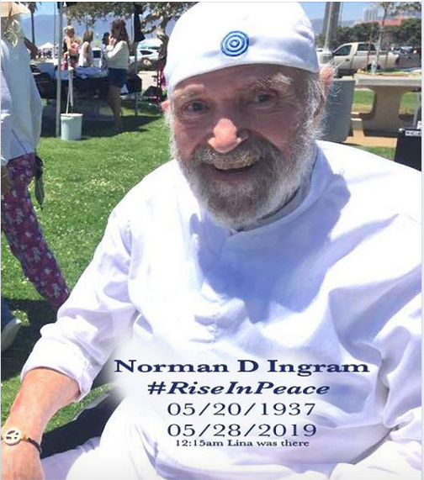

Beloved Sister...how I wish to hug you and cry all my love for Norman....I feel so much impotence to be far in body and can’t be there to help and celebrate our brother farewell. A day before he left and after two days of Norman being in silent and closed eyes. They put Norman on WhatsApp video for me...I shouted to him for several minutes how much I love him, how much he did for so many people as me....and he could hardly open his eyes and whisper 'bye' to me...after that I was so happy and liberated. Paula you know more than no one how much I love my brother-father Norman 'big tree' Ingram. Thank you, Paula, for being such an important piece in this amazing big family we are. Love you Paula and I will work hard to be able to go to next IC to honor our Urantia Missionary Norman. Pradhana Fuchs, Chile

